1)Setup a virtual machine using Ubuntu image.
Step 1: Setup Virtual Machine (Ubuntu – Local)
We’ll use Oracle VM VirtualBox, which is free and widely used.
- Install VirtualBox
Steps:
- Go to VirtualBox official site
- Download for your OS (Windows/Linux/Mac)
- Install normally → Next → Next → Finish

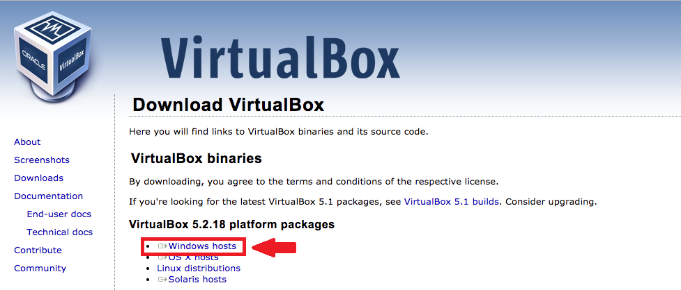

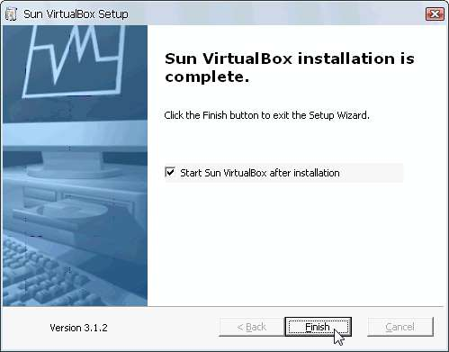
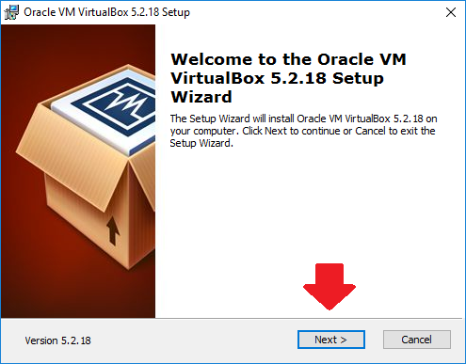

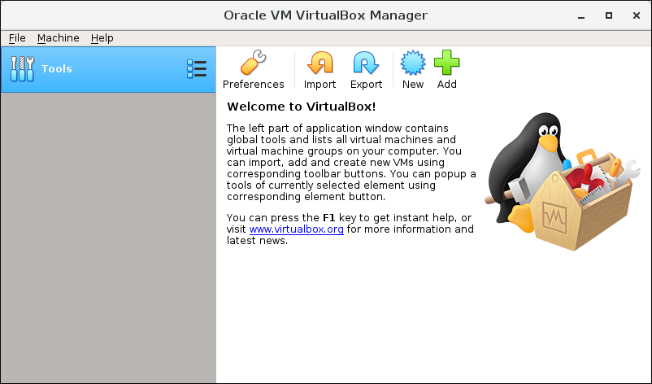

2. Download Ubuntu ISO
From Ubuntu official site
- Download:
Ubuntu 22.04 LTS ISO file
3. Create New Virtual Machine
Steps:
- Open VirtualBox
- Click New
- Fill details:
  - Name → Ubuntu-VM
  - Type → Linux
  - Version → Ubuntu (64-bit)

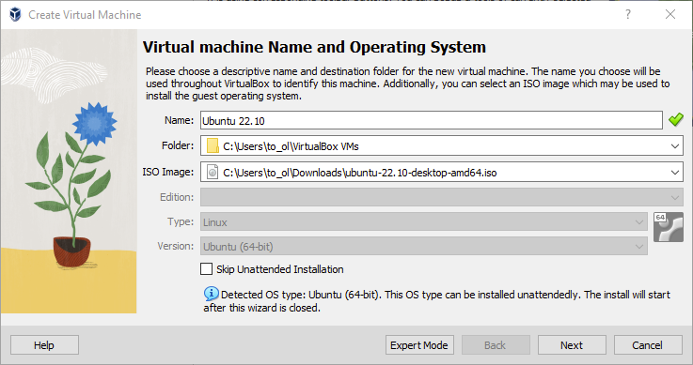
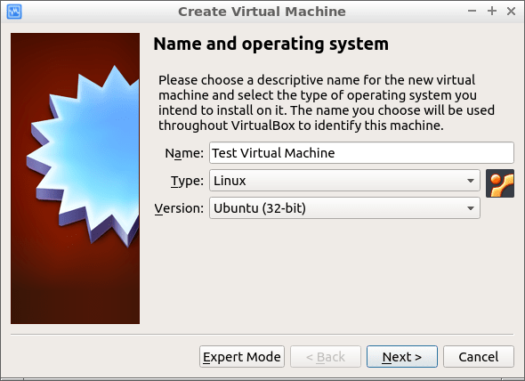

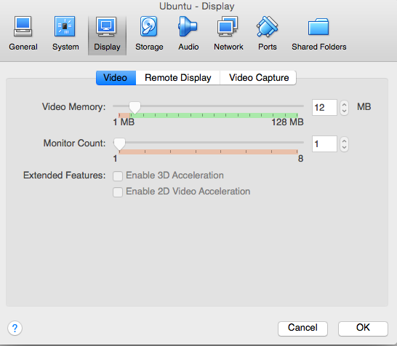
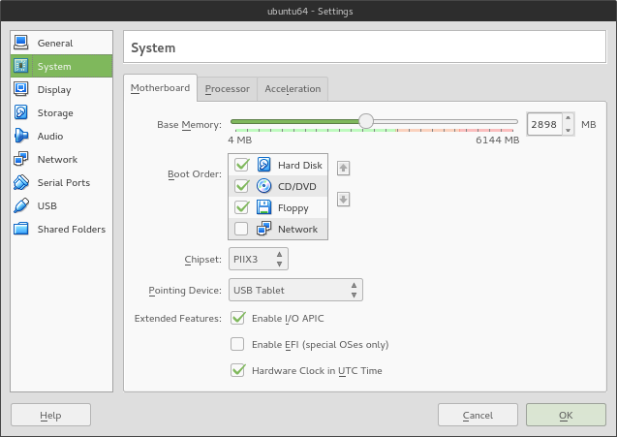

4. Allocate RAM
- Minimum: 2 GB (2048 MB)
- Recommended: 4 GB+
5. Create Virtual Hard Disk
Steps:
- Choose: VDI (VirtualBox Disk Image)
- Select: Dynamically Allocated
- Size:
👉 20 GB (minimum)
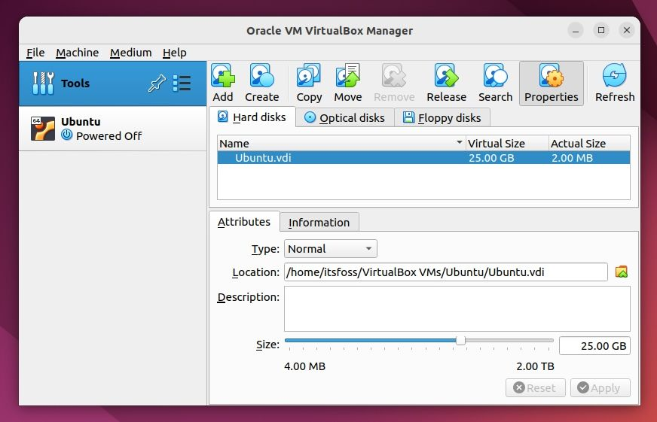
6. Attach Ubuntu ISO
Steps:
- Select VM → Click Settings
- Go to Storage
- Under Controller → Empty
- Click CD icon → Choose ISO file
- Select downloaded Ubuntu ISO
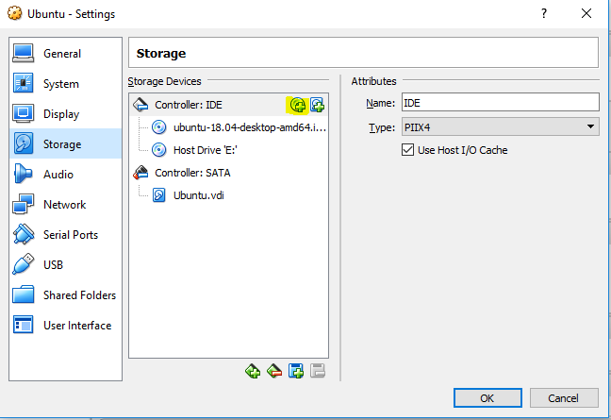
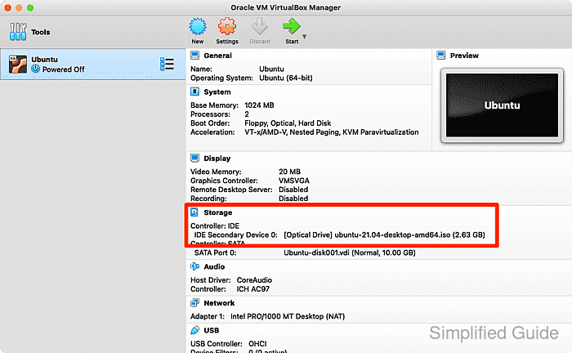

7. Start Virtual Machine & Install Ubuntu
Steps:
- Click Start
- Select → Install Ubuntu
- Follow steps:
  - Language → English
  - Keyboard → Default
  - Installation → Normal
  - Disk → Erase disk (only VM disk, safe)
  - Create username + password
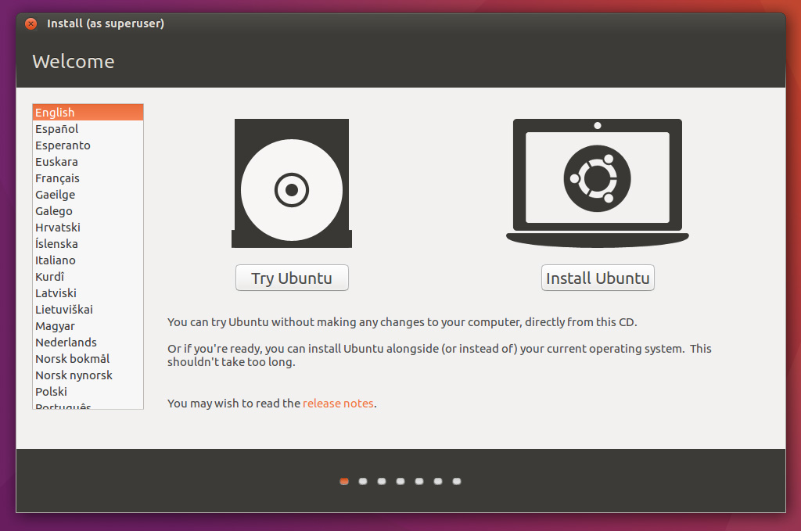
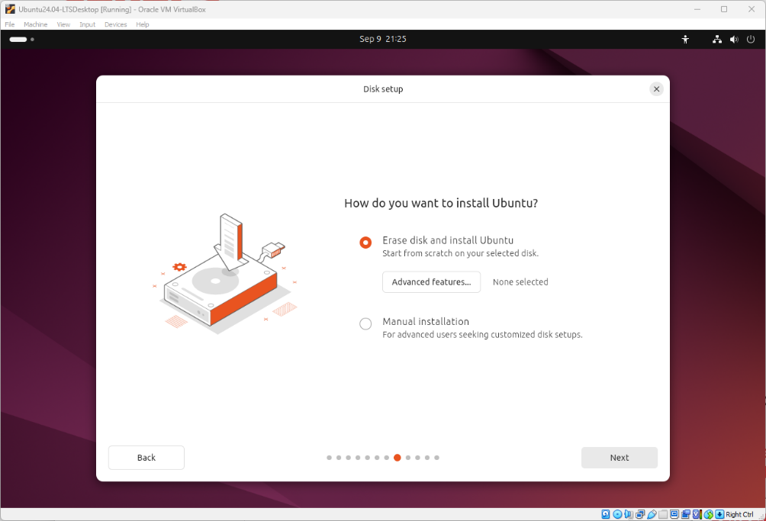

8. Reboot & Login
- After installation completes → Restart
- Remove ISO when prompted
- Login with your credentials
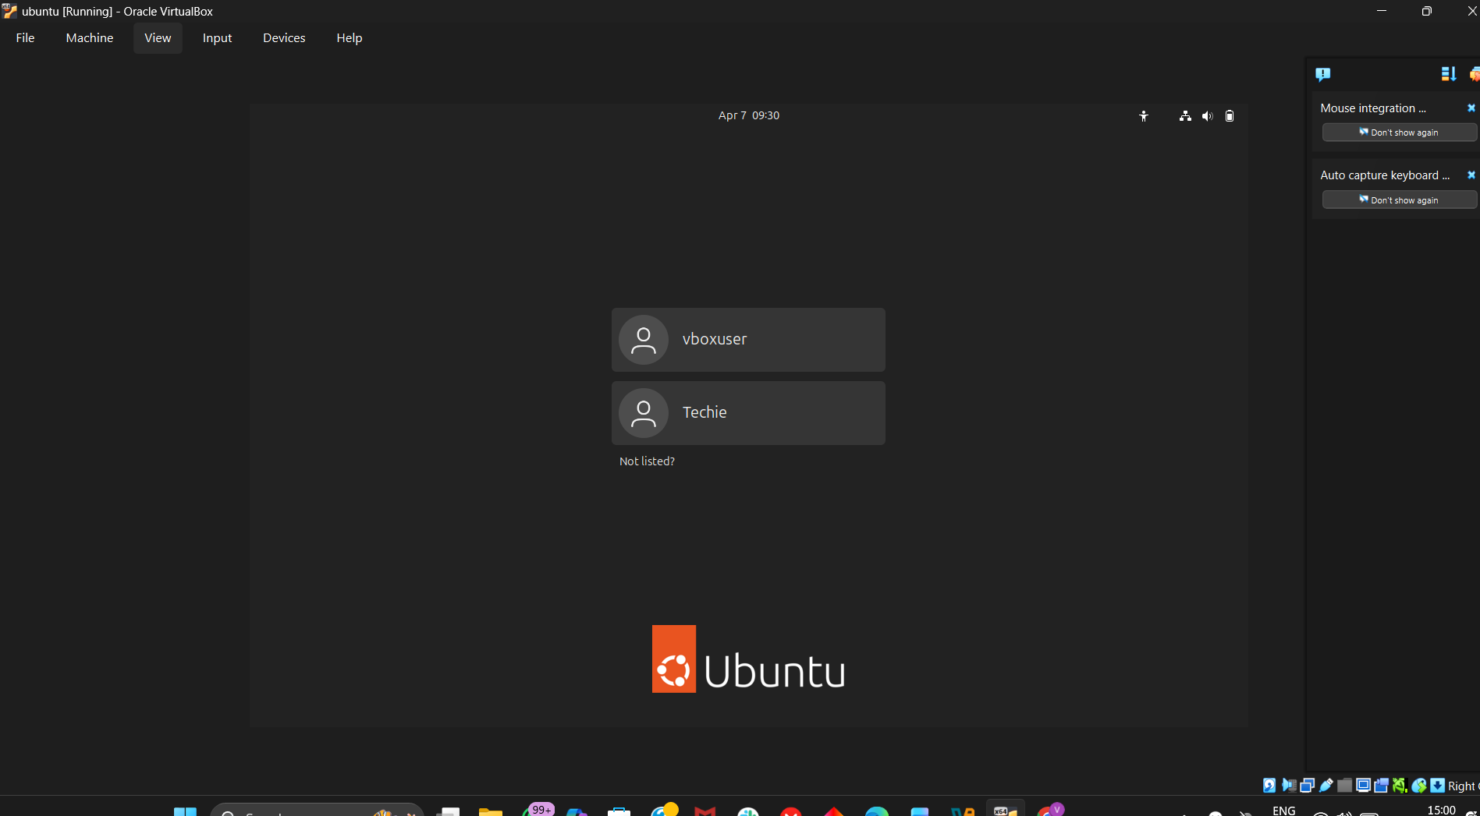

✅ Final Result
You now have:
✔ Ubuntu Virtual Machine
✔ Running locally on your system
✔ Ready for Docker installation

2) Install docker on ec2.
Install Docker on Amazon Linux (EC2)
OS: Amazon Linux

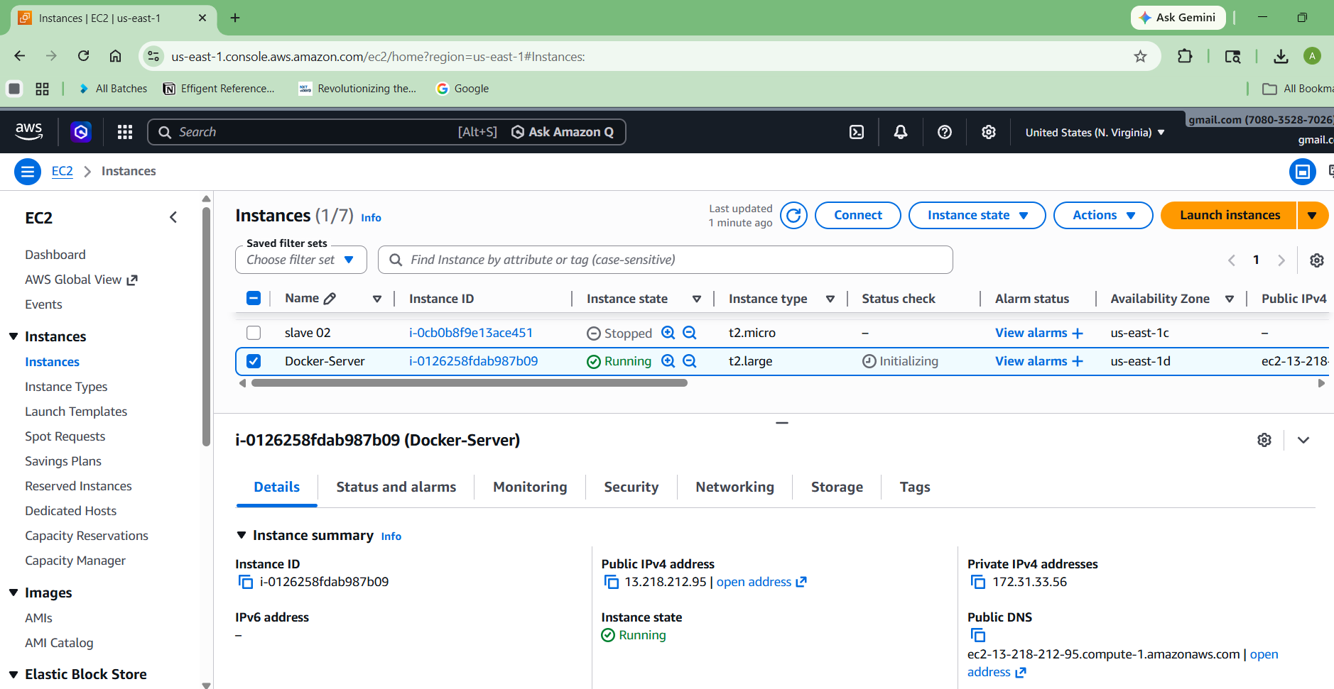

1. Update System
sudo yum update -y
2. Install Docker
For Amazon Linux 2:
sudo yum install docker -y
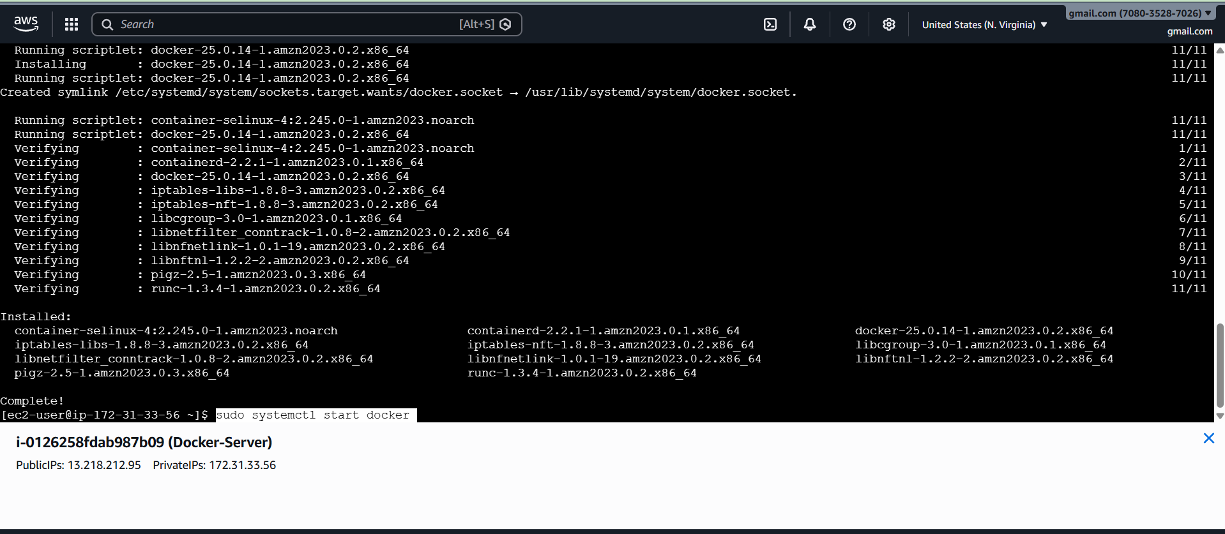

3. Start Docker Service
sudo systemctl start docker
4. Enable Docker (Auto start on boot)
sudo systemctl enable docker
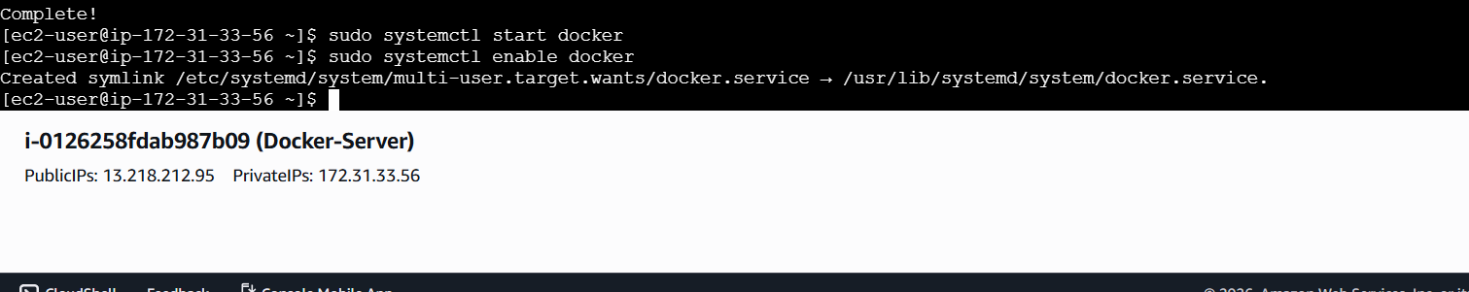
5. Give Permission to User
Default user is usually ec2-user
sudo usermod -aG docker ec2-user
6. Apply Changes
Either:
Option 1 (recommended):
exit
Then reconnect via SSH
Option 2:
newgrp docker

7. Verify Docker Installation
docker --version
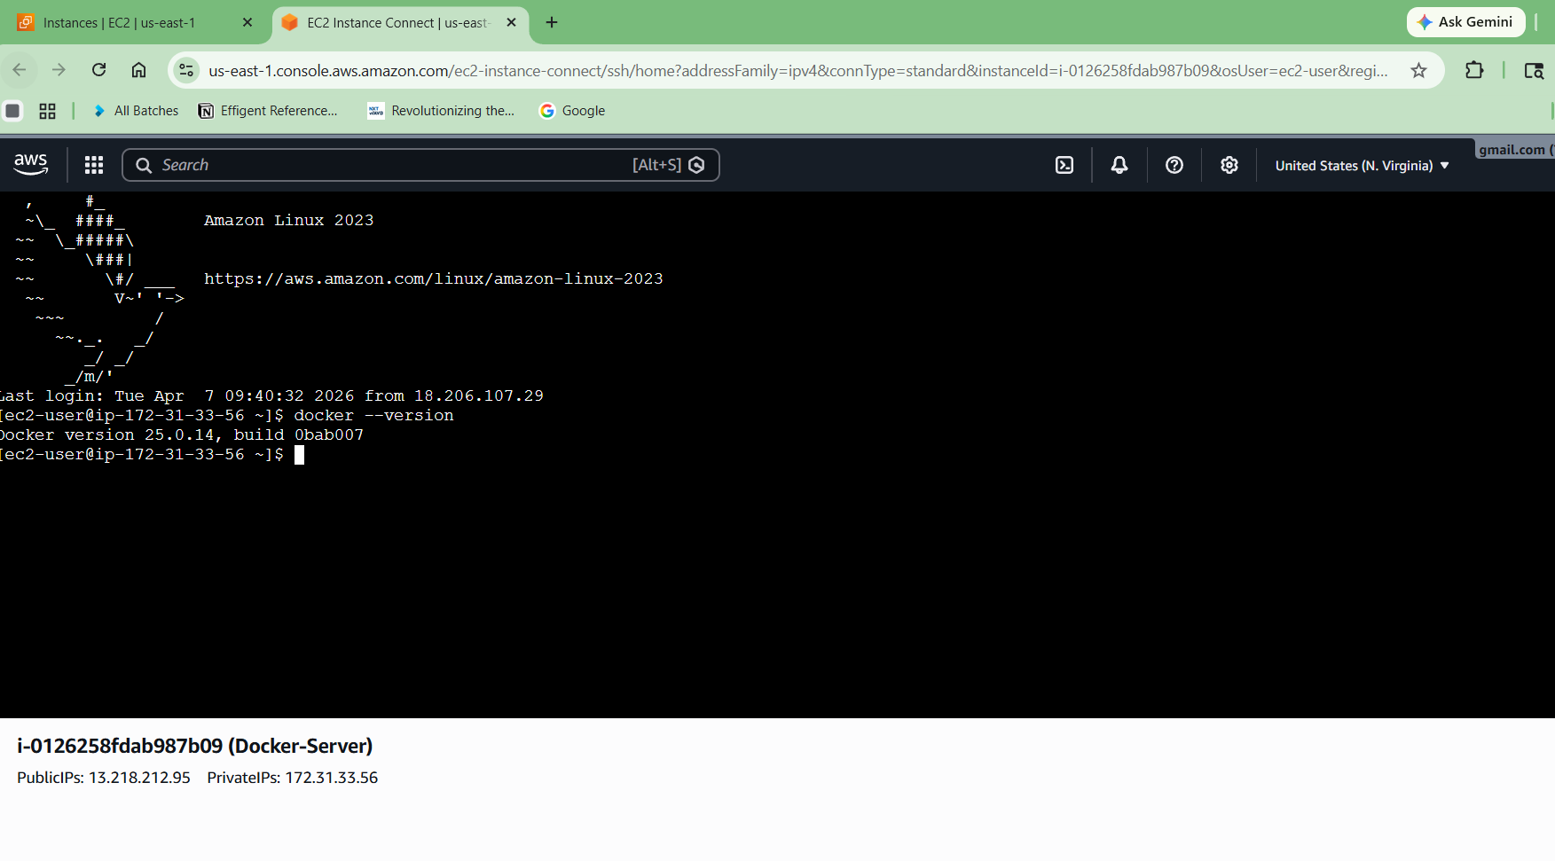

Example output:
Docker version 20.x.x

Test Docker (Optional but Important)
docker run hello-world
If everything is correct, you’ll see:
Hello from Docker!
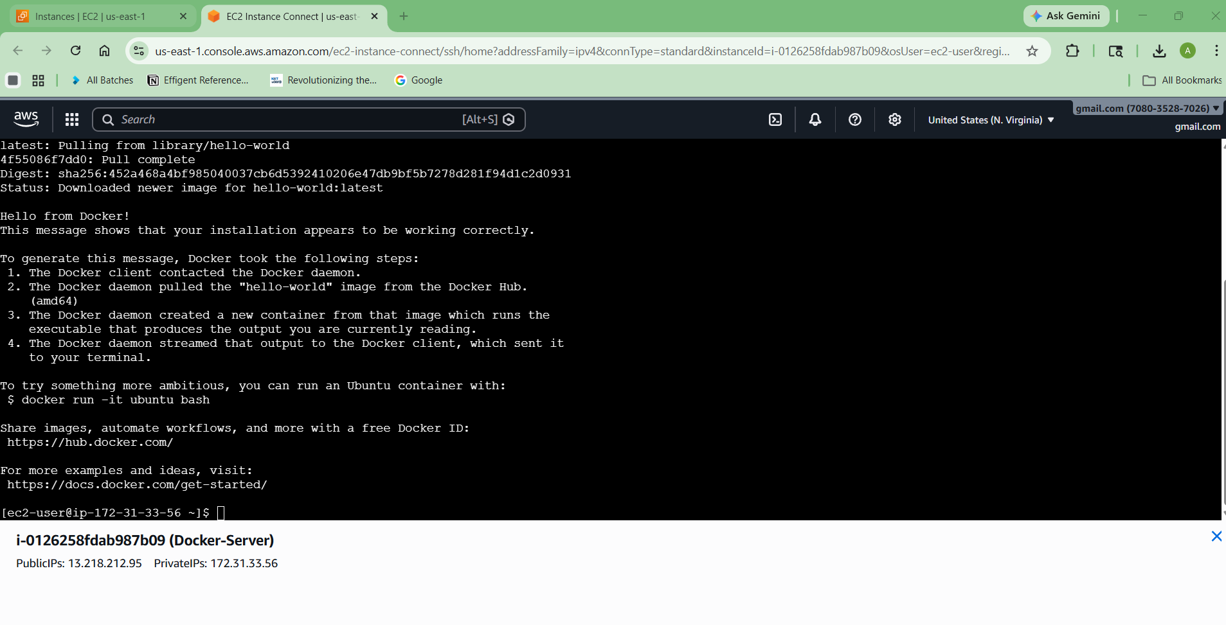
Done!
Now you have:
✔ Docker installed on Amazon Linux
✔ Service running
✔ User permission configured

3) Pull 5 docker images.(nginx,apache tomcat,ubuntu,jenkins,sonarqube)
Pull 5 Docker Images
We will use official images:
- NGINX
- Apache Tomcat
- Ubuntu
- Jenkins
- SonarQube

Commands:
docker pull nginx
docker pull tomcat
docker pull ubuntu
docker pull jenkins/jenkins:lts
docker pull sonarqube

docker pull nginx

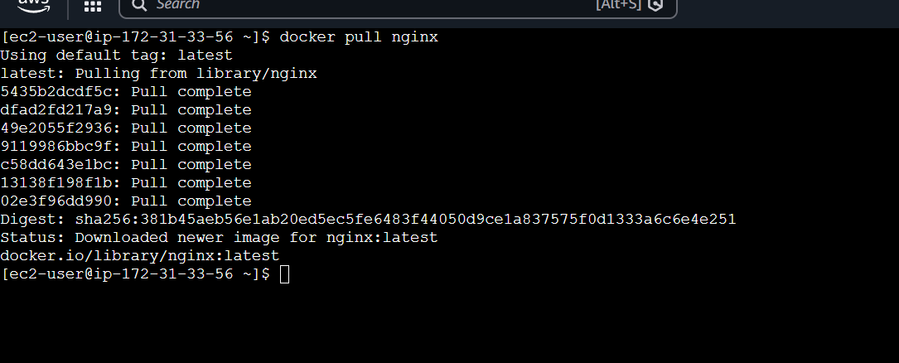

docker pull tomcat

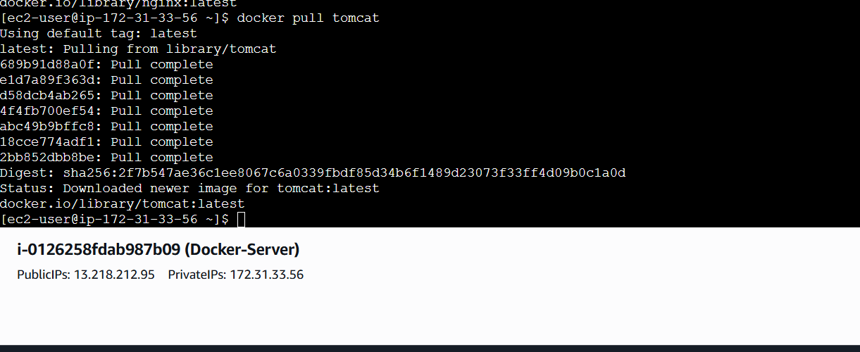

docker pull ubuntu

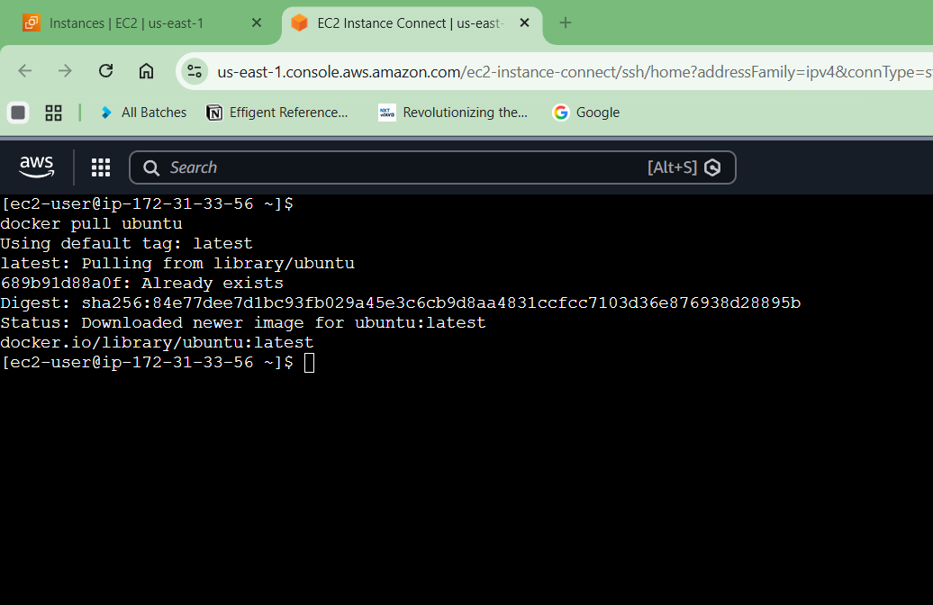

docker pull jenkins:2.60.3

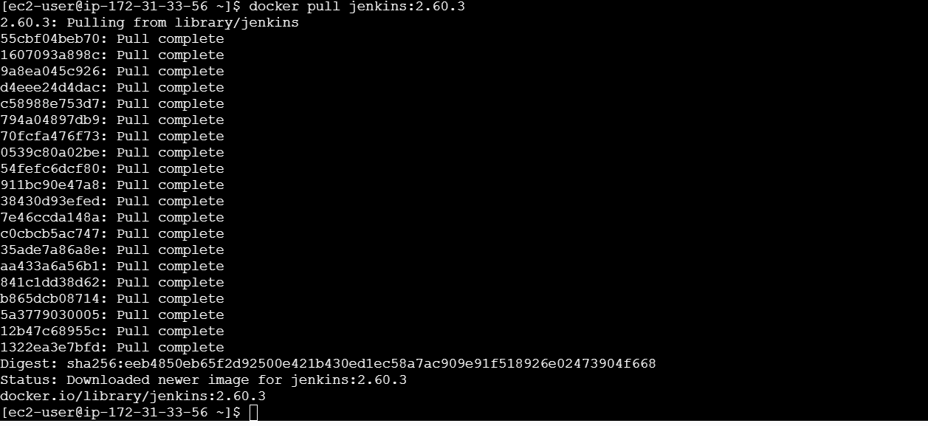

docker pull sonarqube

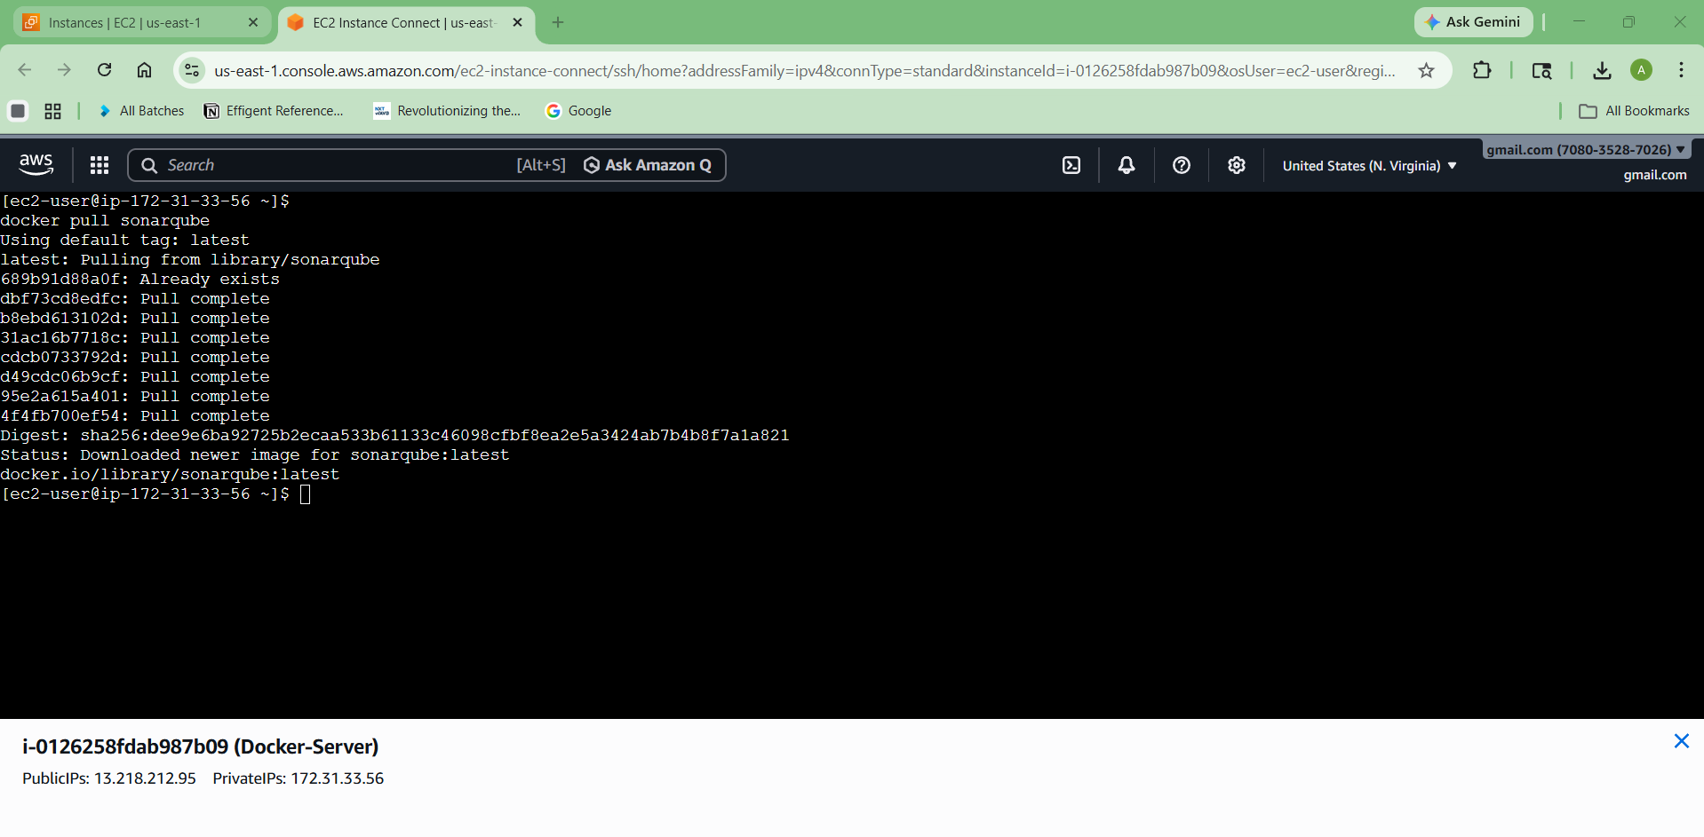

Check:
docker images

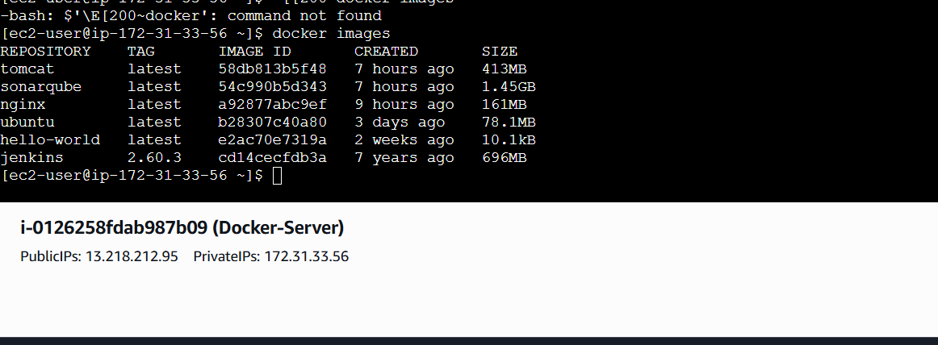

4) Run nginx container and expose on port 81.
Run Command:
docker run -d -p 81:80 --name nginx-container nginx

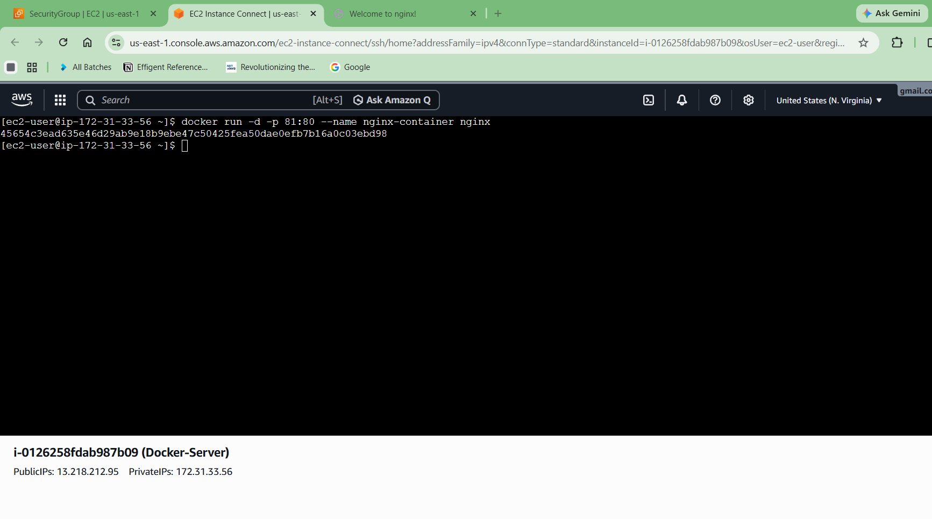
Verify:
Open browser:
http://<EC2-Public-IP>:81
You should see Nginx welcome page

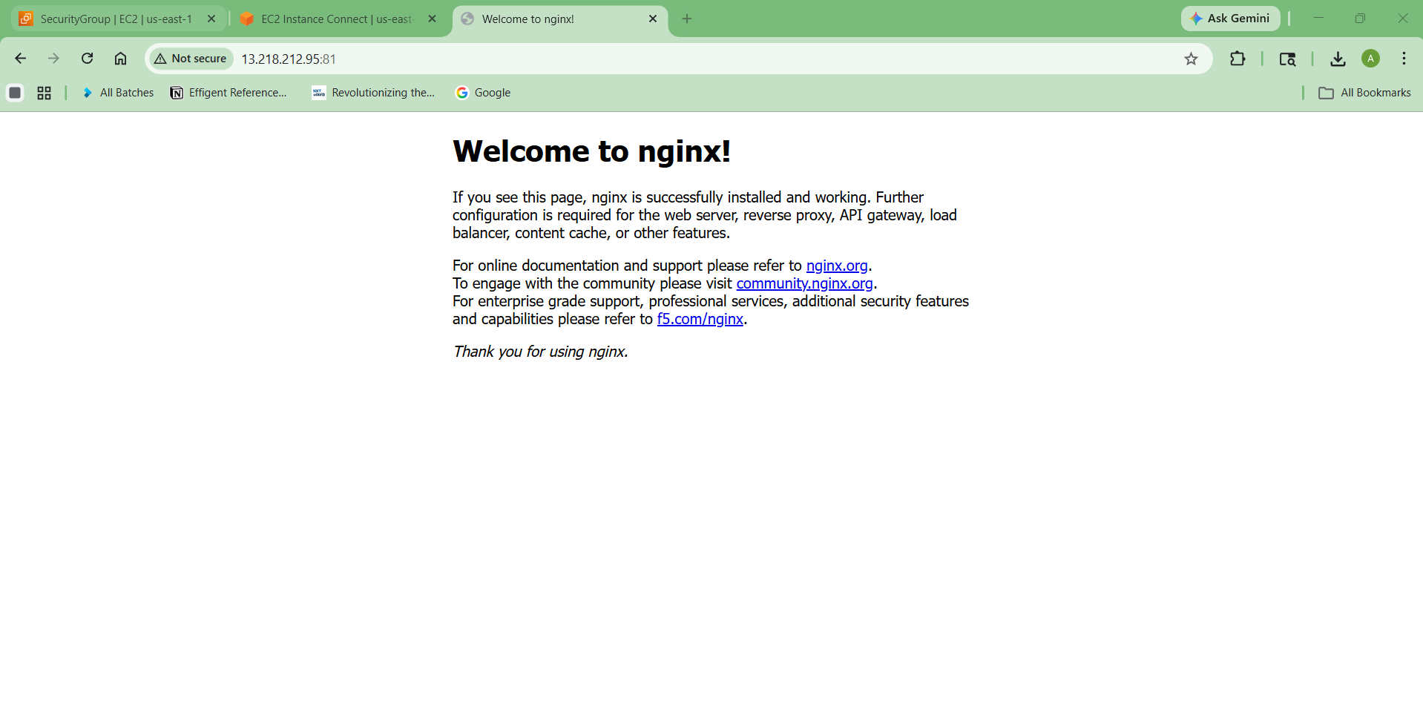

5) Delete the apache tomcat image from local.
First check image:
docker images
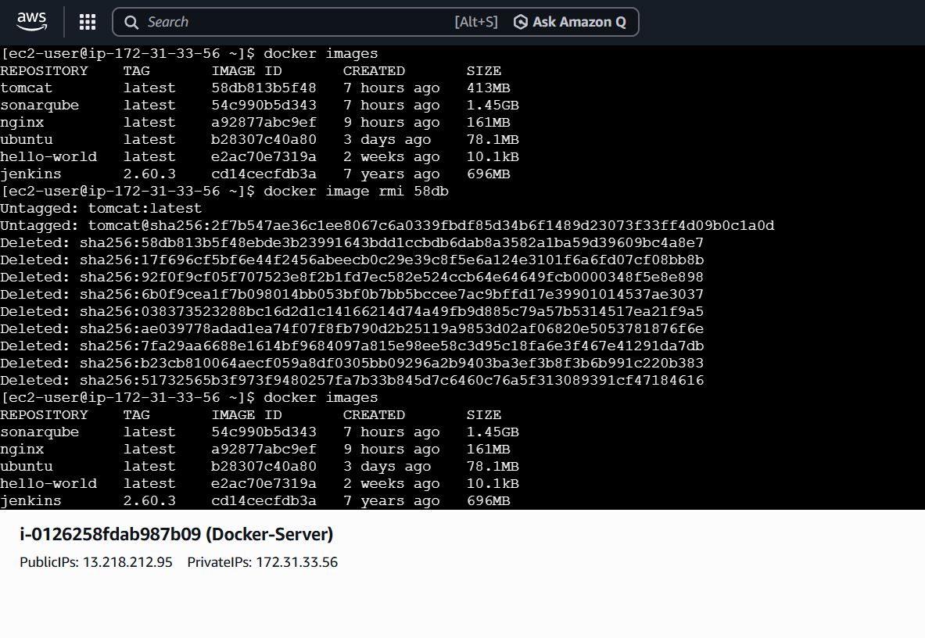

Remove:
docker rmi tomcat
If error:
docker rmi -f tomcat
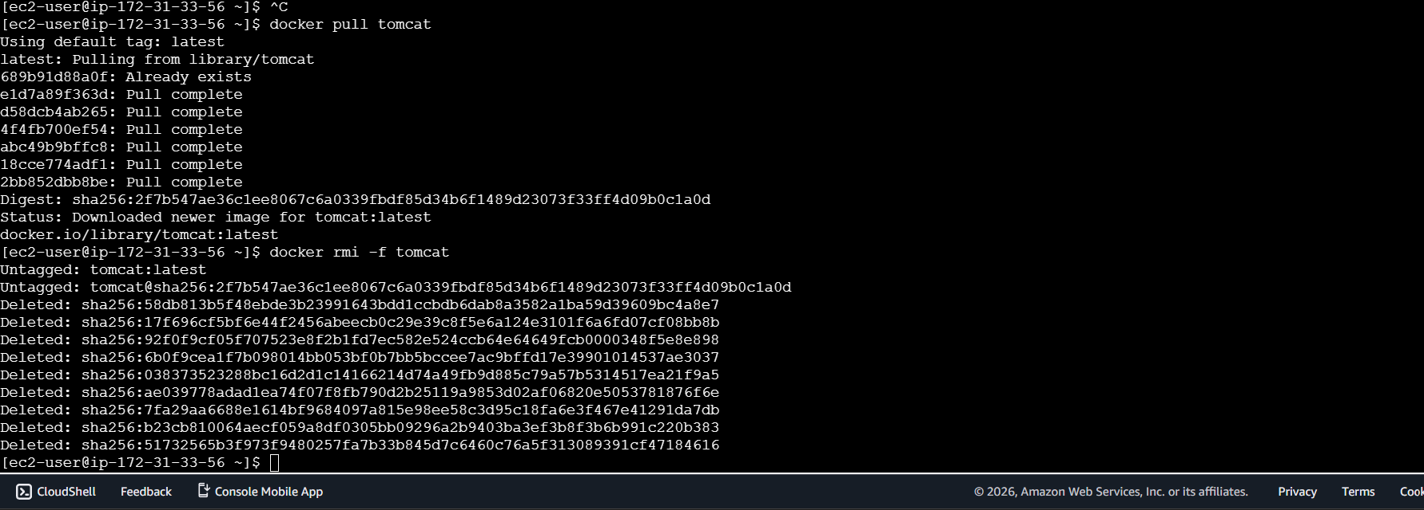

docker image rmi 58db (containerId)

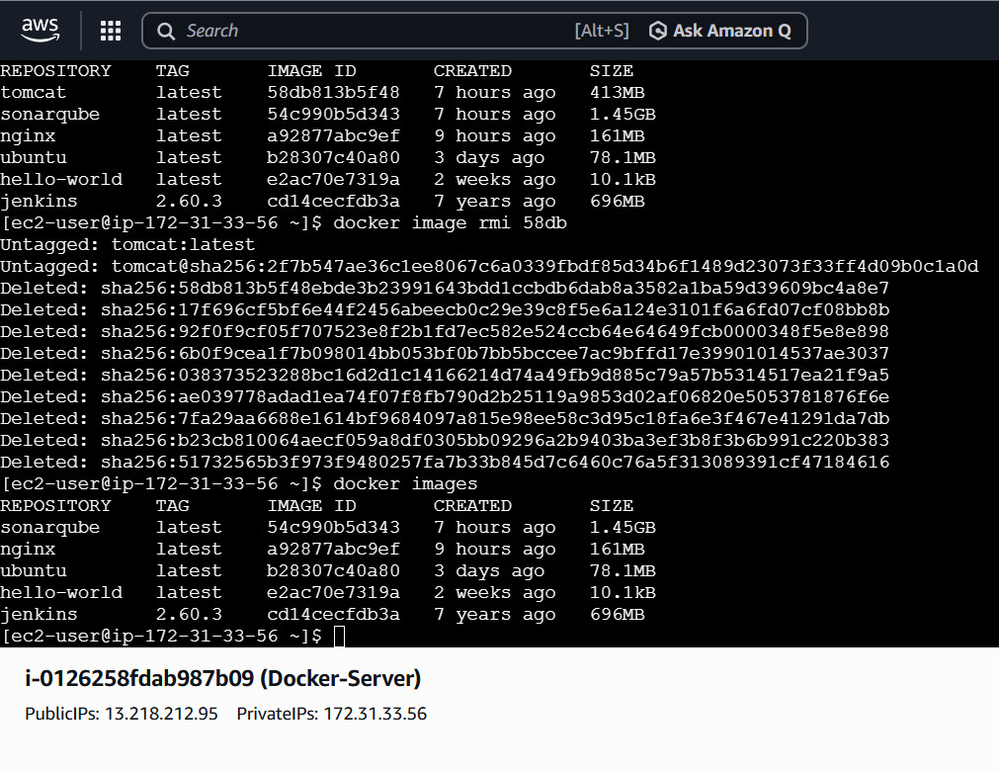

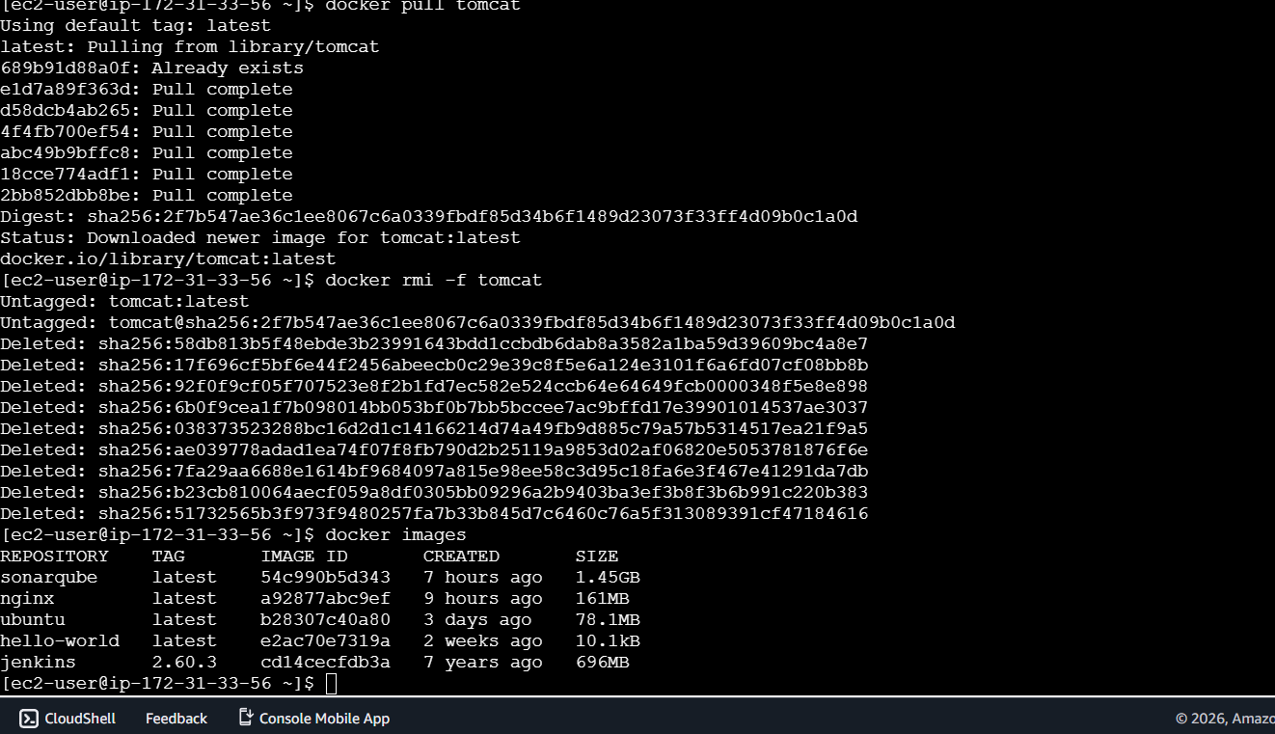

6) Inspect the jenkins image,sonarqube image.

Jenkins:
docker image inspect cd14cecfdb3a (Container Id)

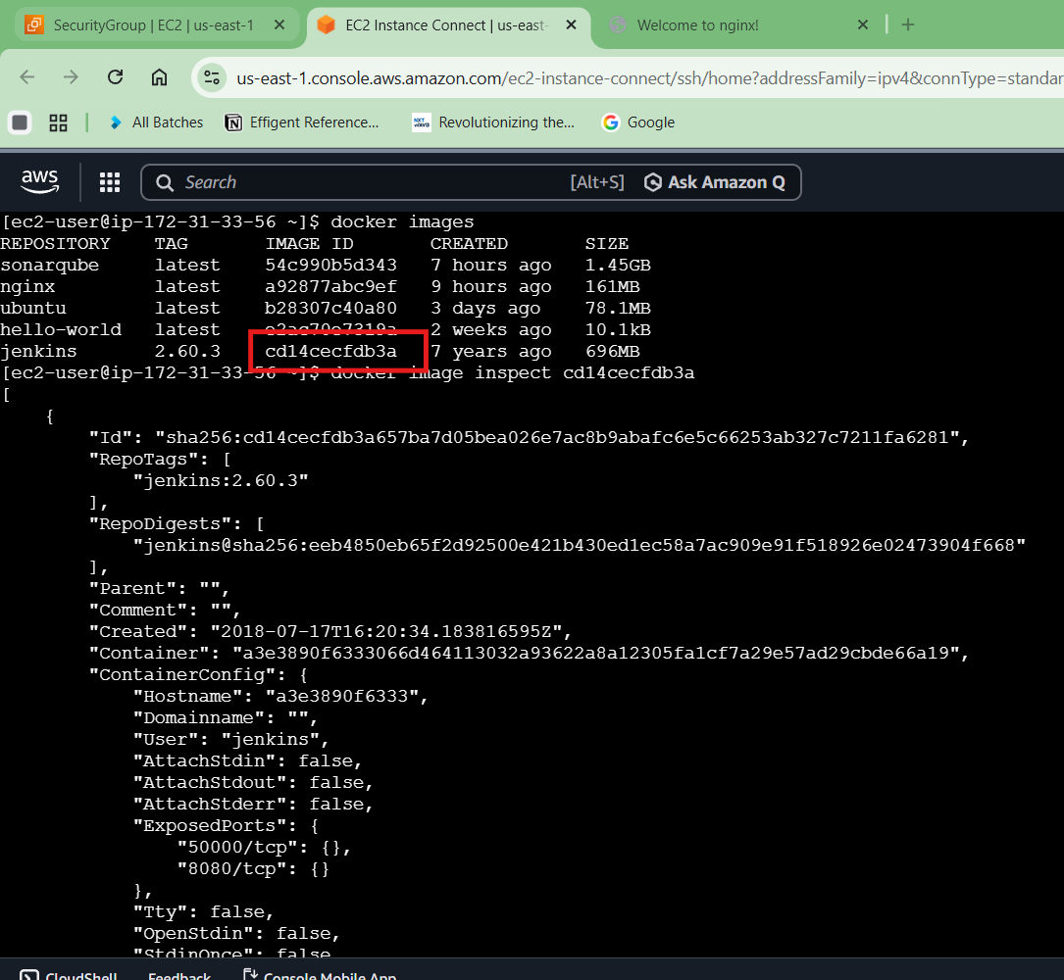

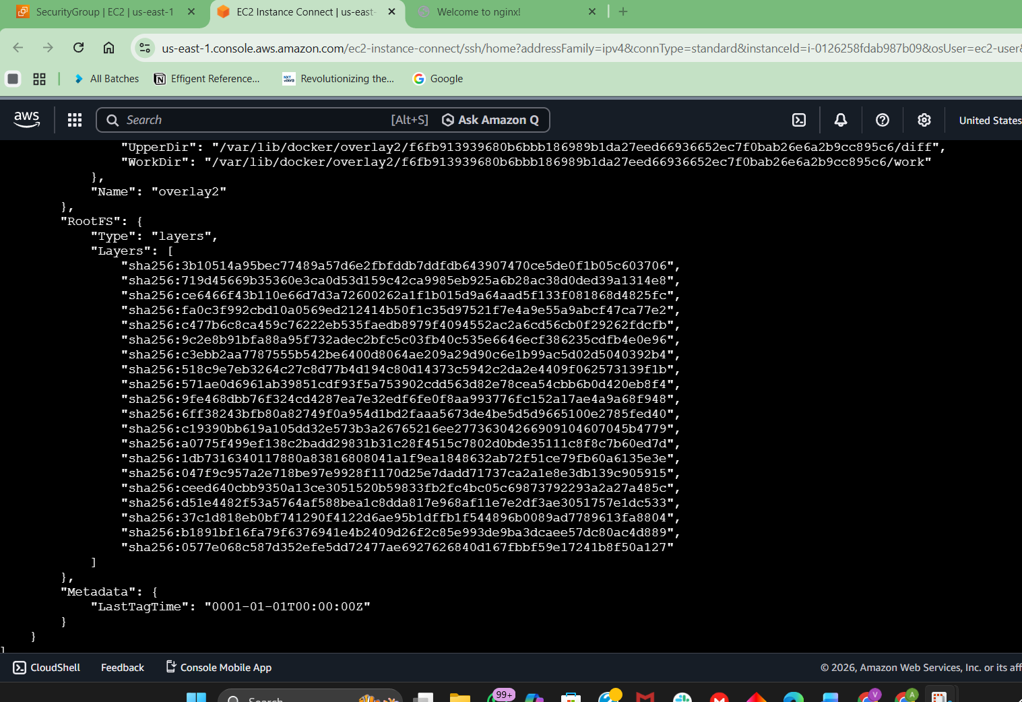

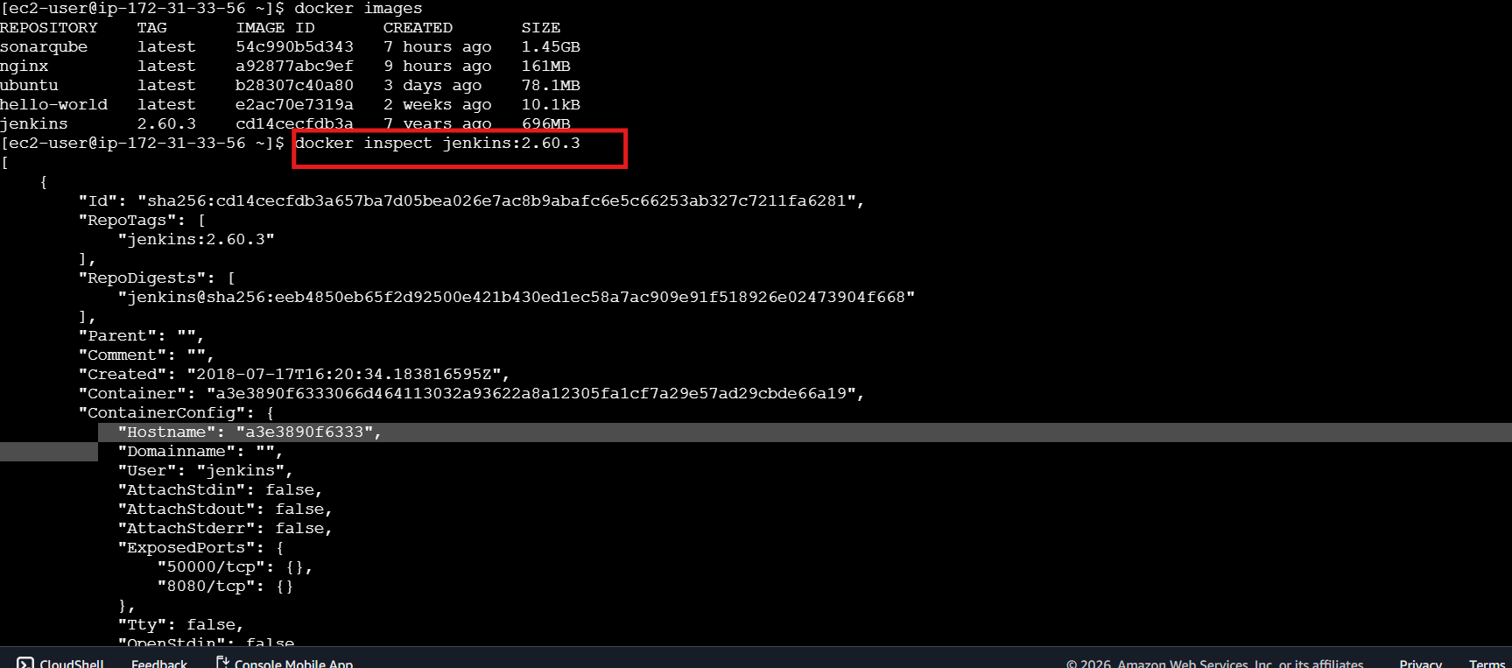

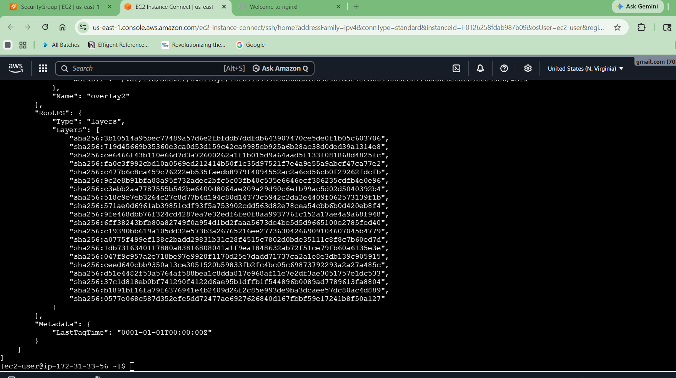
SonarQube:
docker inspect sonarqube
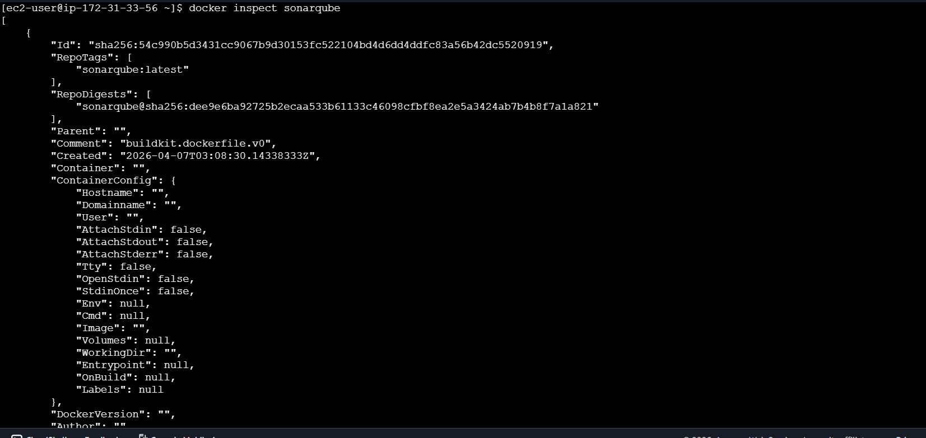

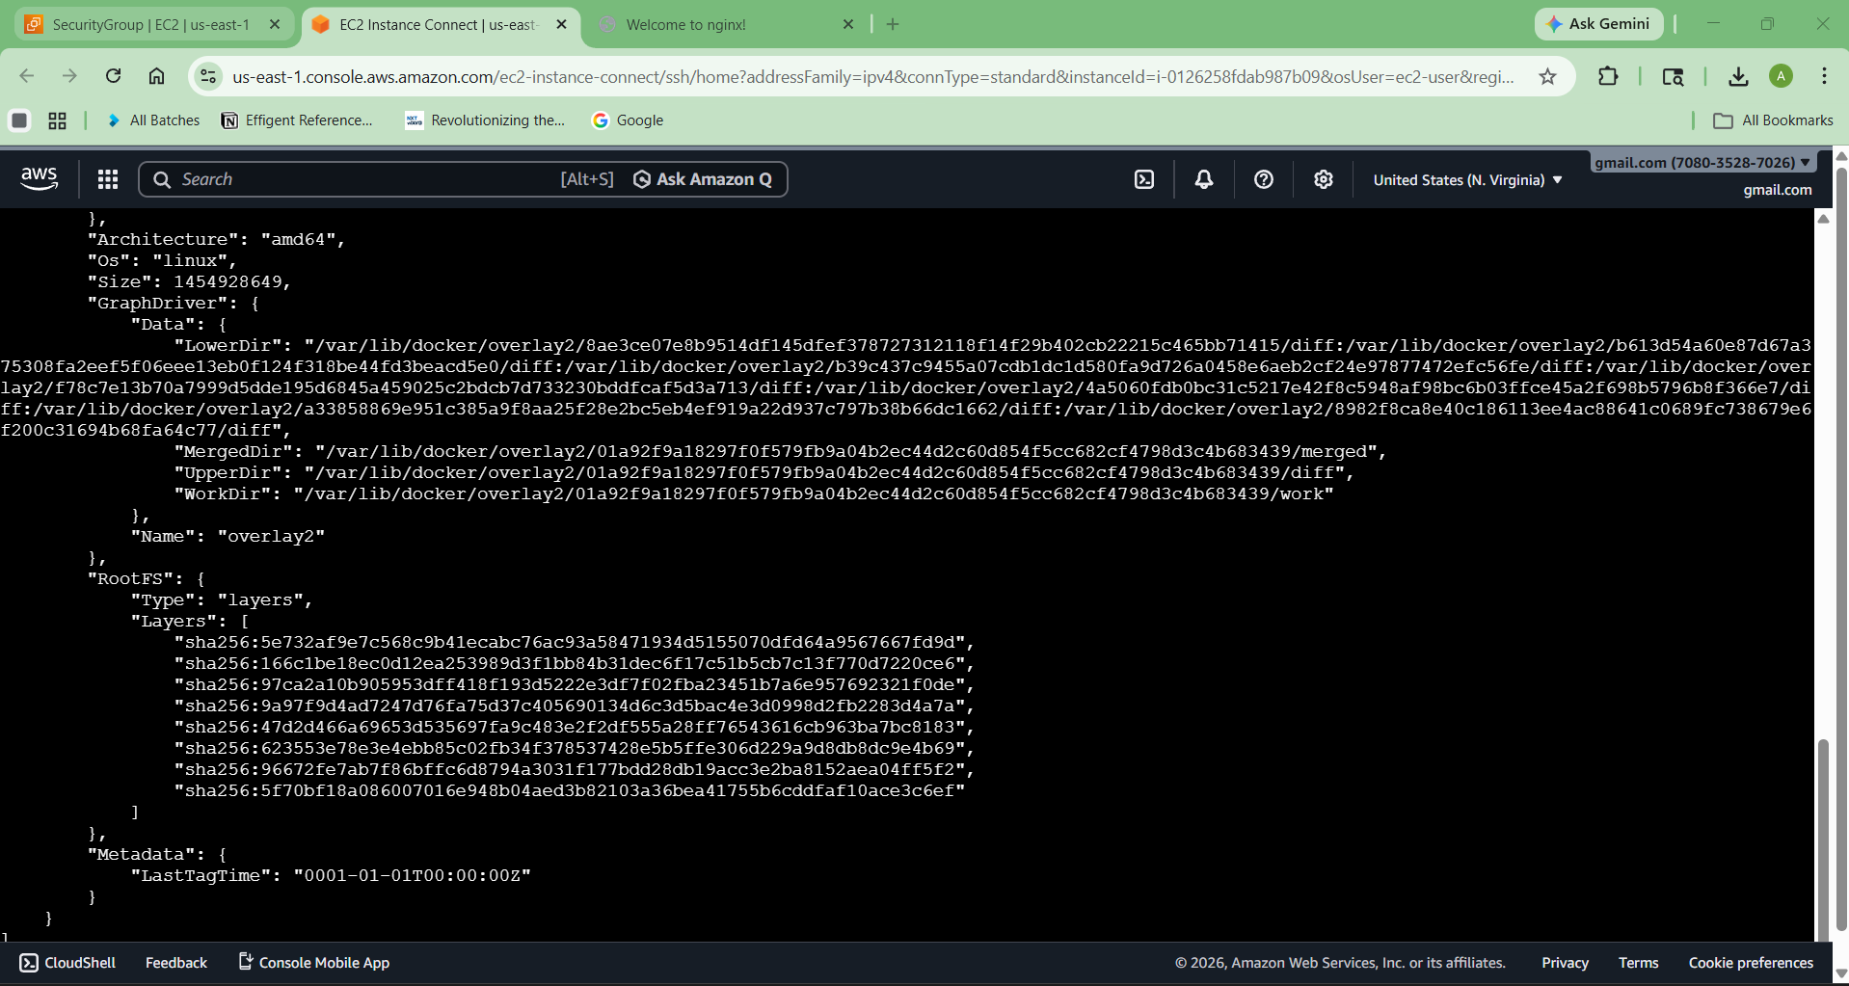

This shows:
- IP
- Volumes
- Ports
- Environment variables

7) Run jenkins contianer and run one sample job.

Run Jenkins:

docker run -d \
-p 8080:8080 \
-p 50000:50000 \
--name jenkins \
jenkins/jenkins:lts
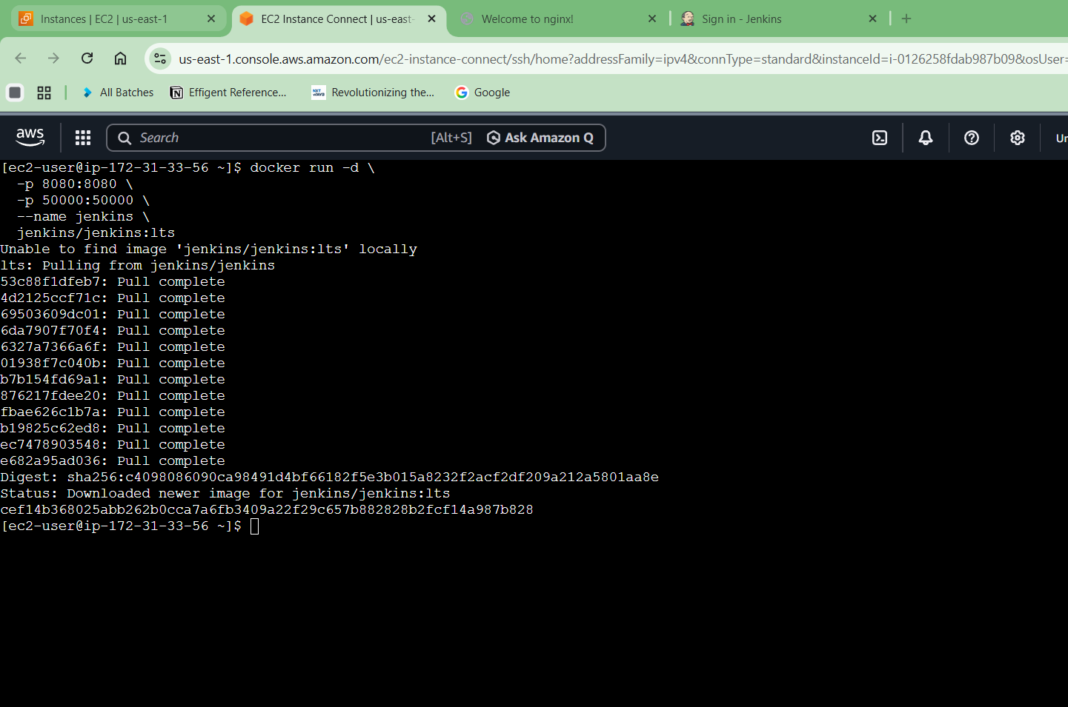

Unlock Jenkins
Get password:
docker exec jenkins cat /var/jenkins_home/secrets/initialAdminPassword

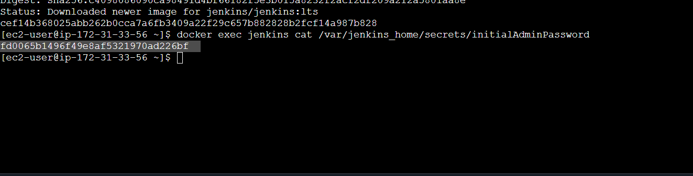
Open:
http://<EC2-IP>:8080
Paste password → Install suggested plugins
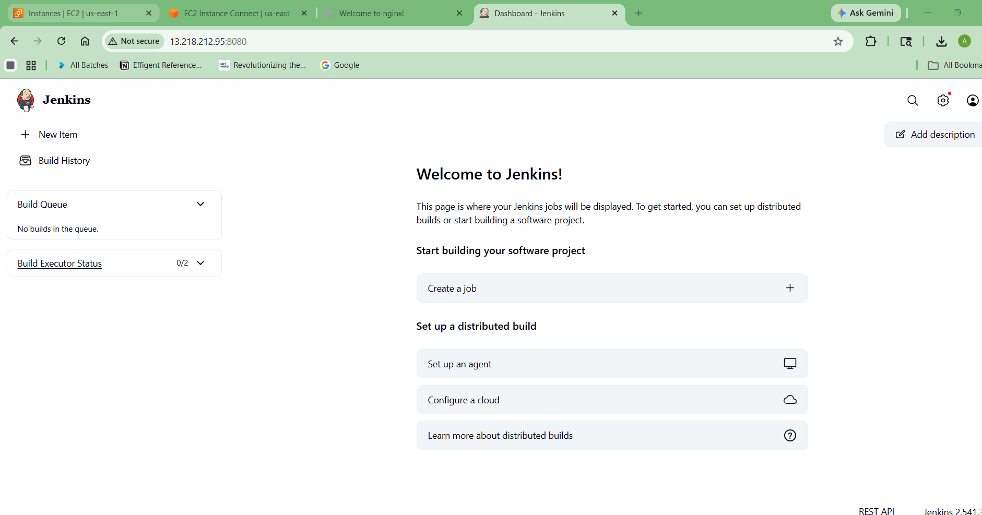

Create Sample Job
- Click New Item
- Enter name → test-job
- Select Freestyle Project
- Click OK
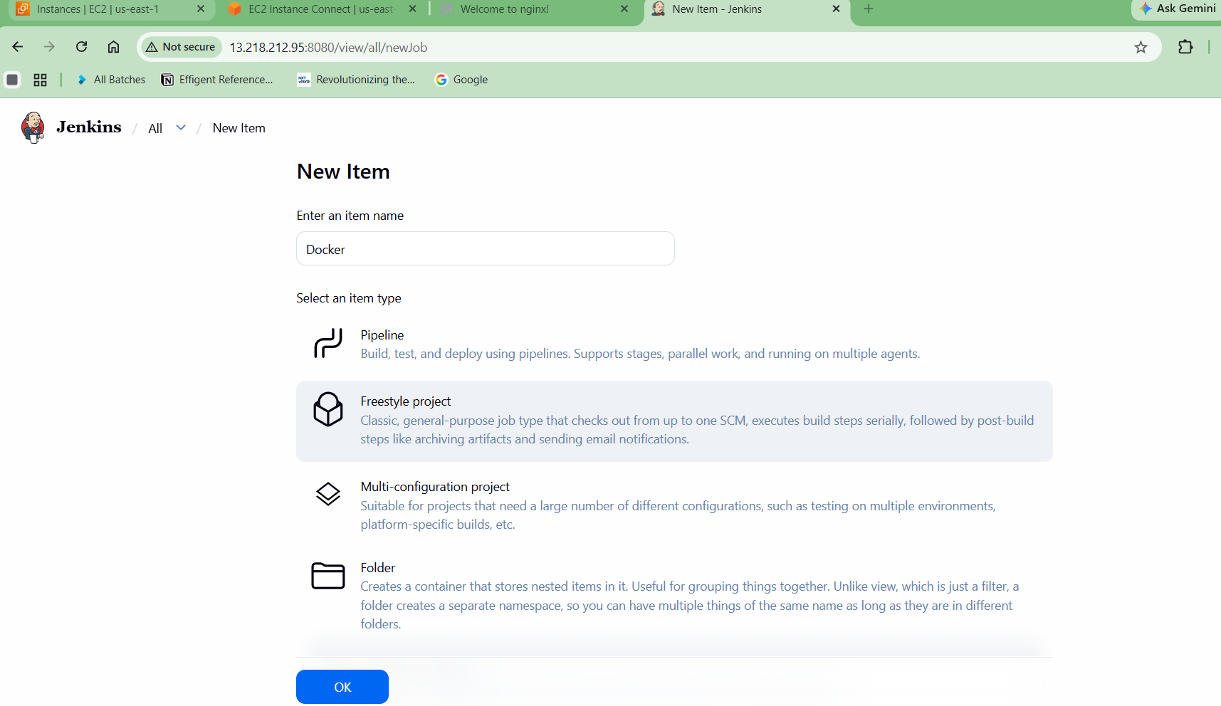

Add Build Step:
- Go to Build → Execute Shell
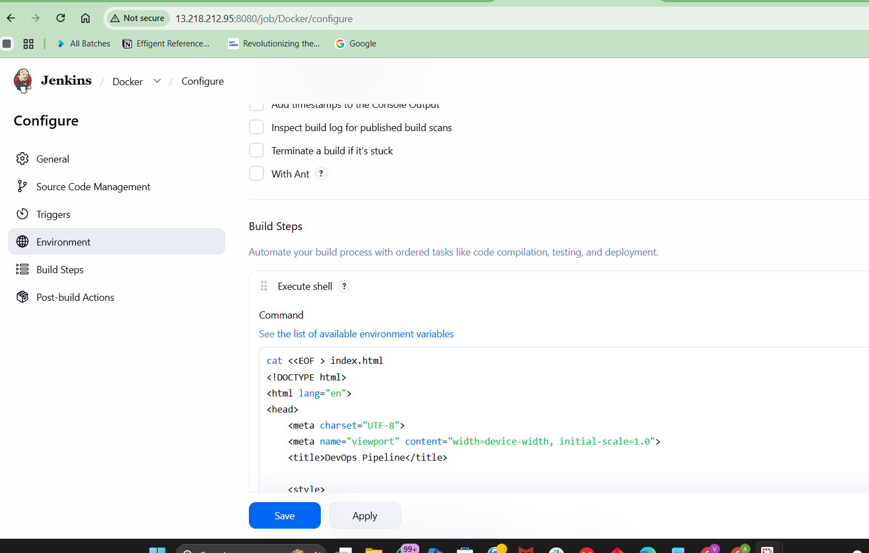

Add Build Step:
- Go to Build → Execute Shell
echo "Hello DevOps from Jenkins "
- Click Save

▶️ Run Job:
Click Build Now
Check Console Output:
Hello DevOps from Jenkins
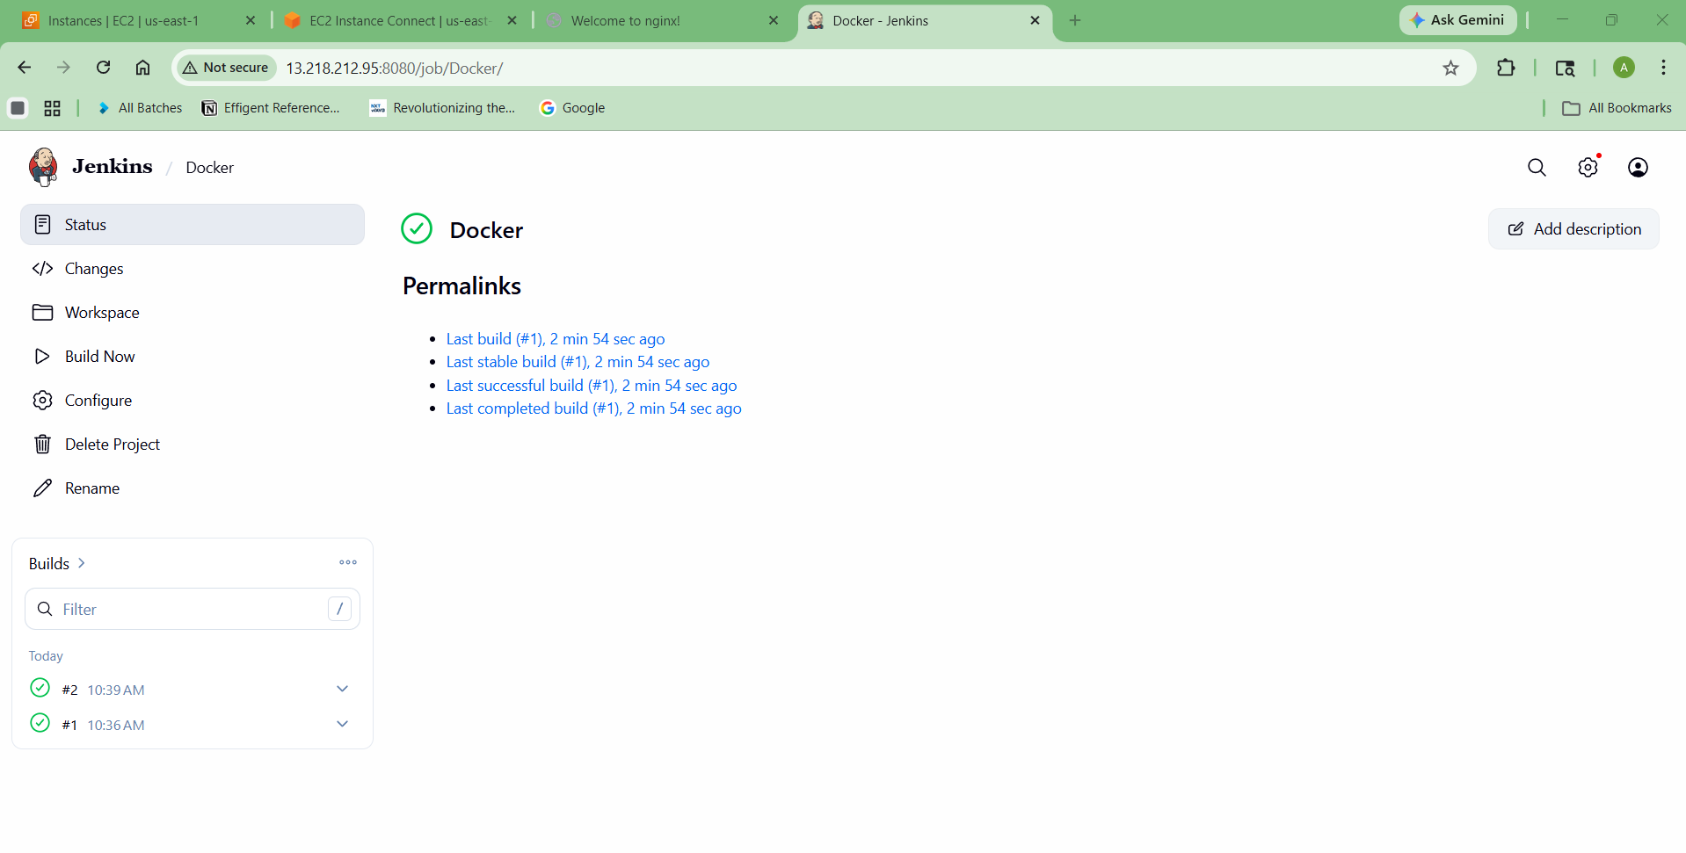

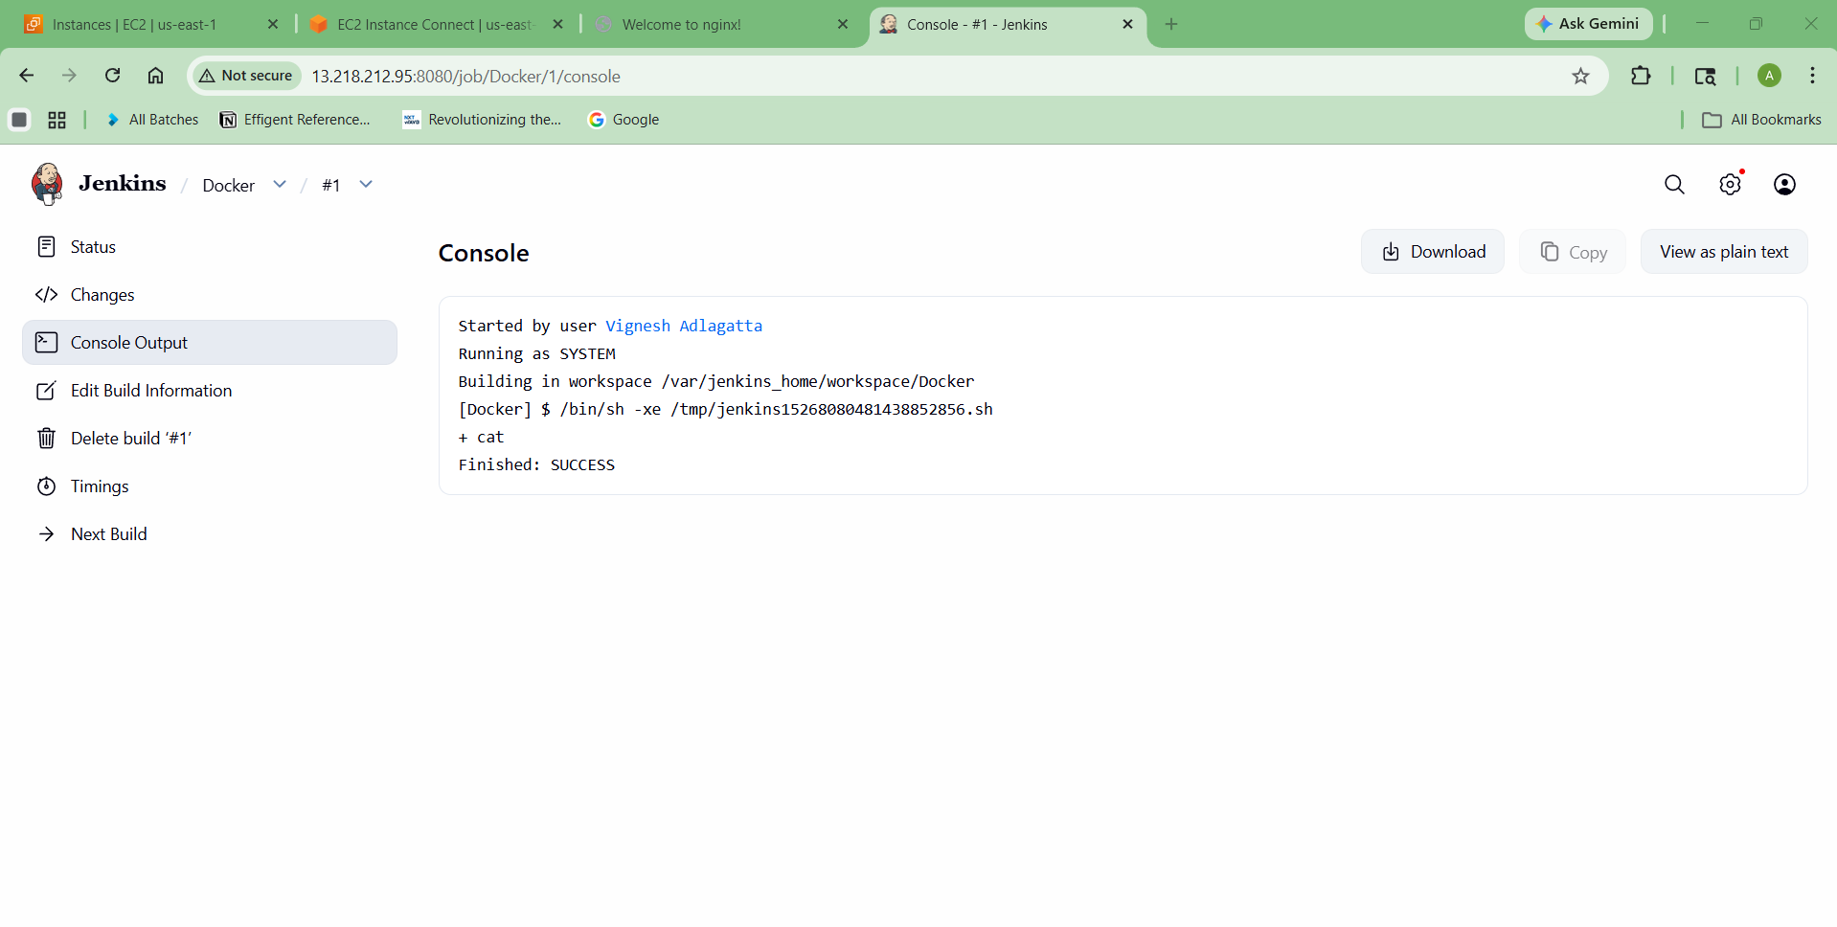

Final Result
You have successfully:
✅ EC2 Ubuntu VM
✅ Docker installed
✅ 5 images pulled
✅ Nginx running on port 81
✅ Tomcat image deleted
✅ Inspected images
✅ Jenkins running + job executed

